# | Name | Designation | Profile with Photograph* | Qualification | Professional Experience | Any Specific Skill to be displayed on web | List of Publications
1. | Abbas Saleem Khan | Professor |  | BDS, MPhil, PhD, CHPE, PGD | 12 Years | - | 41 Articles in National and International peer reviewed Journals  List Attached in Annexure-1
2. | Nasiha Bashir | Professor | 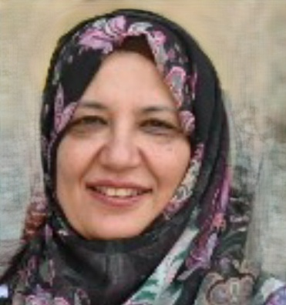 | BDS, MPhil, PhD, CHPE | 30 years (24 years teaching +6 years private clinical practice) |  | 19 Articles in National and International peer reviewed Journals. List attached in Annexure-2
3. | Fatima Iqbal | Associate Professor |  | BDS, MPhil, PhD | 14 Years | - | 22 Articles in National and International peer reviewed Journals  List Attached in Annexure-3
4. | Tehmina Nausheen | Associate Professor | 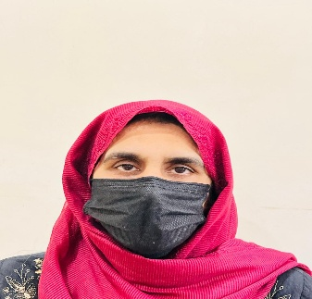 | BDS, MPhil, CHPE, PGD | 29 years  1996-2009  13 years (Alkhidmat Hospital Peshawar)  2011-2026  16years  (Peshawar Dental College and Hospital |  | 24 Articles in National and International peer reviewed Journals  List attached in Annexure 4
5. | Anoshia Zahid | Senior Lecturer | 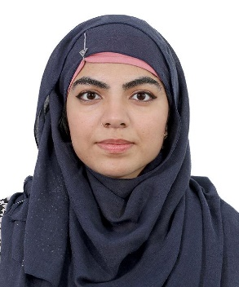 | BDS, MPhil, CHPE | 20 months | Gold medalist in Mphil (Oral Pathology)  Principal author of the Book (published)  Title “Diseases of Salivary Glands”  ISBN 978-627-94976-0-4 | 2 Articles in National peer reviewed Journals. List of articles attached in Annexure-6
6. | Karishma Ali | Senior Lecturer |  | BDS, MPhil, MHPE,CHR | 5 years |  | 10 Articles in National and International peer reviewed Journals.  List of articles attached in Annexure-5
*. Not mandatory for female faculty

